Name:Kolipaka Sanjana
Roll.no:2303a52139
Batch:41
Task 1: AI-Generated Logic Without Modularization (Fibonacci Sequence
Without Functions)
Prompt:Code for fibonacci series without modular design
Code: 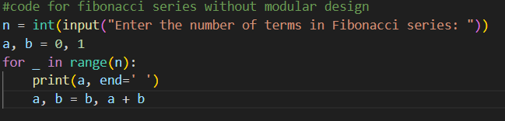
Output:
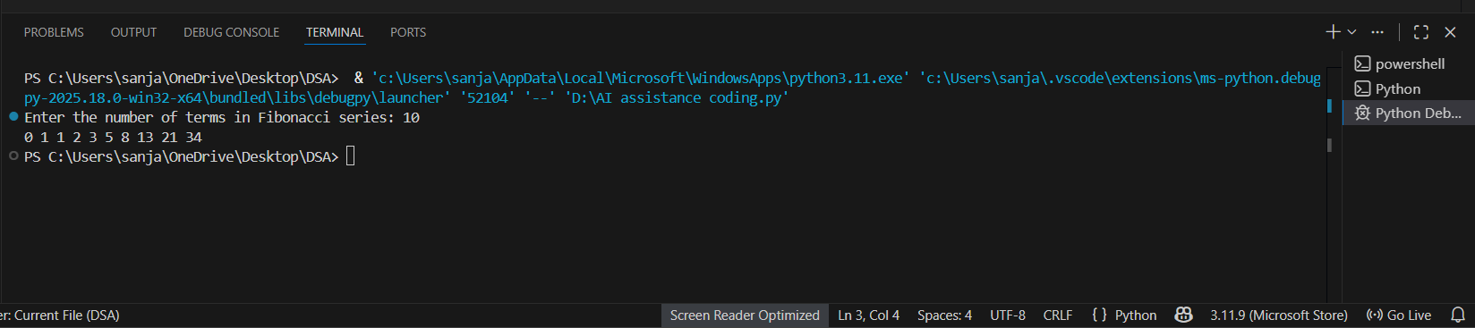
Justification: By completing this task, we have printed the required Fibonacci series up to n terms without using modularization. The logic is written directly in the main program without defining any user-defined functions. The program accepts user input for the number of terms and generates the Fibonacci sequence using a single for loop.
Task 2: AI Code Optimization & Cleanup (Improving Efficiency)
❖ Scenario
The prototype will be shared with other developers and needs
optimization.
❖ Task Description
➢ Examine the Copilot-generated code from Task 1 and improve it by:
➢ Removing redundant variables
➢ Simplifying loop logic
➢ Avoiding unnecessary computations
➢ Use Copilot prompts such as:
▪ “Optimize this Fibonacci code”
▪ “Simplify variable usage”
Prompt: optimize the code below by removing unnecessary variables and improving readability and avoiding unused computations.
Code: 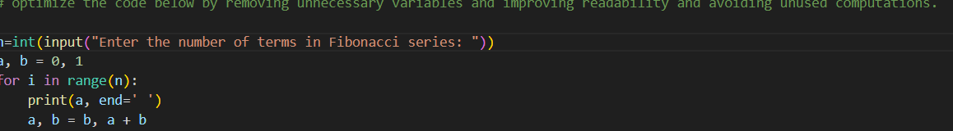

Output:
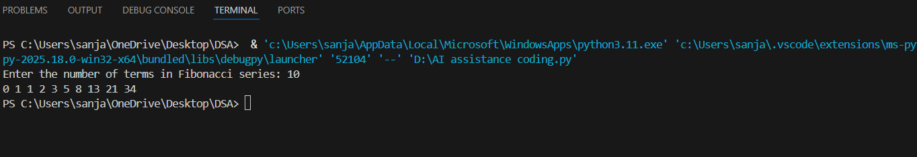
Justification:

Task 3: Modular Design Using AI Assistance (Fibonacci Using Functions)
❖ Scenario
The Fibonacci logic is now required in multiple modules of an application.
❖ Task Description
Use GitHub Copilot to generate a function-based Python program that:
➢ Uses a user-defined function to generate Fibonacci numbers
➢ Returns or prints the sequence up to n
➢ Includes meaningful comments (AI-assisted)
Prompt: #modular design for fibonacci series
Code:
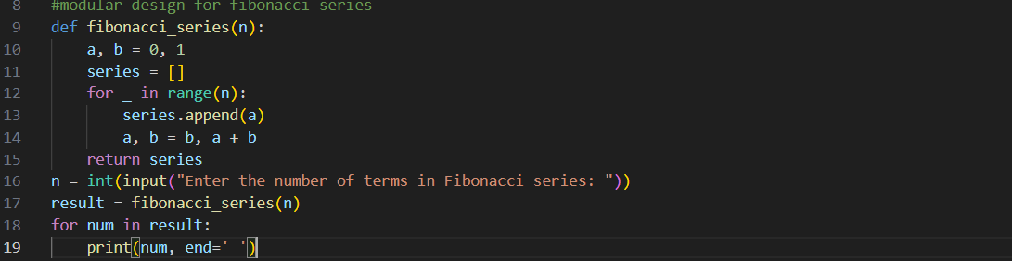
Output:
Justification: By completing this task, we implemented the Fibonacci series using a user-defined function. The function contains all the Fibonacci logic, which makes the code modular and easy to reuse. Using modularization helps to organize the code properly and allows the same function to be used in different programs. This method makes the code easier to read, easier to debug, and more suitable for large applications.
Task 4: Comparative Analysis – Procedural vs Modular Fibonacci Code
PROMPTS:
Procedural: Write a code for printing fibonacci series up to n terms without using functions
Modular: Optimized version of Fibonacci series up to n terms using functions
CODE:
Procedural

MODULAR:
Outputs:
JUSTIFICATION:
By this task , we are able to find the difference between Procedural(without using functions) and Modular(with using functions). The main use of function is
• Reusability of the code
• Easy to Debug
• Code Clarity
• Suitable for large systems
By observing, we can analyze that using modular method is a better and clean approach

Task 5: AI-Generated Iterative vs Recursive Fibonacci Approaches (Different Algorithmic Approaches for Fibonacci Series)
PROMPTS:
Iterative approach: write a code fibonacci series up to n terms using iterative approach Recursive approach : write a code fibonacci series up to n terms using recursive approach CODE:
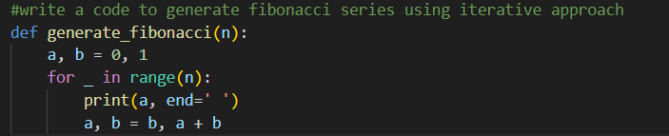
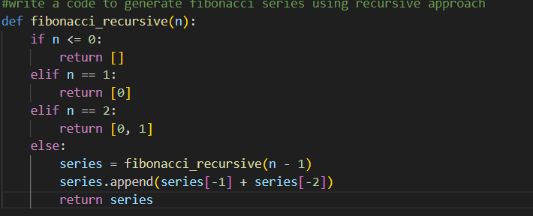
OUTPUT:

Justification: Using a loop (iterative method) to find Fibonacci numbers is usually better because it’s faster, uses less memory, and can handle big numbers easily. The recursive method (using functions that call themselves) is slower, uses more memory, and can crash if the number is too large. That’s why in real programs, loops are preferred over recursion.

